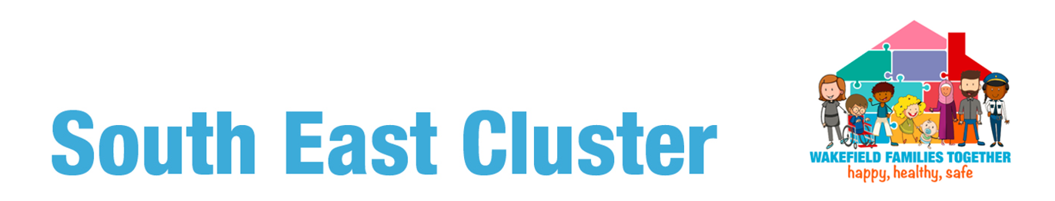

**Contact Cedars or Havercroft Family Hub on 01977 722305**

**or pop into reception for more details**

**Welcome to Wellbeing**

**The Parental Wellbeing group is an 11-week**

**programme for parents or carers**

**Our aim**

* **Support parents and carers who are experiencing low mood and anxiety**
* **Help parents feel more in control and less stressed**
* **Meet guest speakers from other agencies, CAMHS, Police, Talking Therapies, WDH, GamCare, Solicitors, LGBT+, Spectrum to name a few**
* **Advice, Information & support is given in areas such as future aspirations, managing & identifying stress, bereavement, domestic abuse, gaming and gambling, current crime trends, staying safe online, drugs & alcohol misuse**

**Knowledge is Power**

**A private and confidential space with no distractions where you can choose to engage as little or as much as you like**