Help Guide for student to access seesaw

Type into your internet search address bar, seesaw or you can copy or click on the link below.
https://web.seesaw.me/

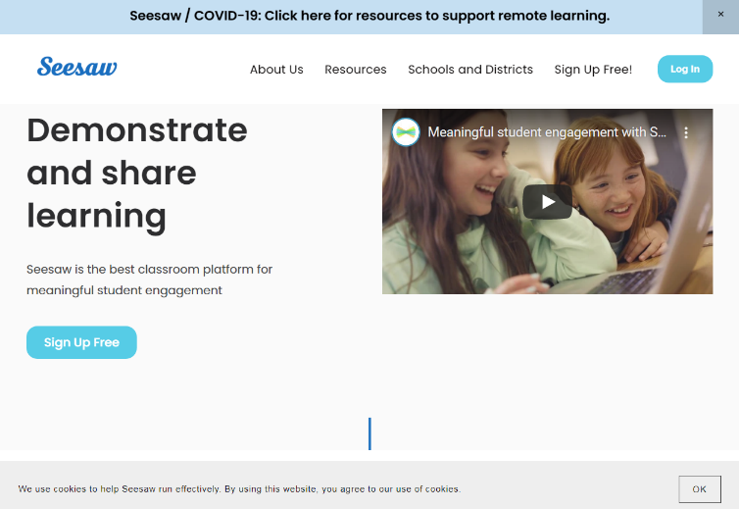
Click on, Log In.

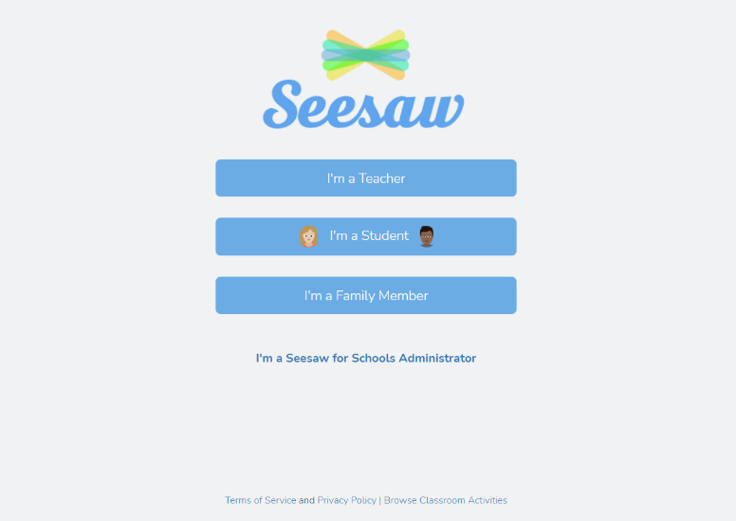
Click on, I’m a Student.

Enter the email address your child had given at school and the password.
