Week | News story | Focus question | UN Article | British value
24th  August | Property information site, Zoopla, have said there was a surge of activity during the first month of lockdown, when virtual reality (VR) viewings of new-build properties tripled. | Can virtual experiences match real life ones? | 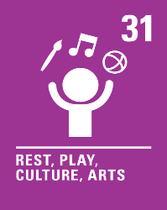 | Individual Liberty - Virtual reality can provide a wealth of experiences and opportunities that we may not otherwise be able to have. We could experience space exploration, or life in a different period of history!
31st  August | A mother, who has recently set up a not-for-profit company to provide toys for children with disabilities, has been told her toys are empowering for children by one of her customers. | Should there be more toys reflecting our differences? | 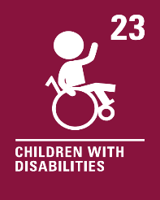 | Mutual Respect - We are all unique and should respect and celebrate our own and others’ differences.
7th  September | A tribe in Brazil have chosen to block a highway that cuts through the Amazon as the Brazilian government is not complying with a list of demands that includes aid to help with the impact of COVID-19. | Should we always stand up for our communities? | 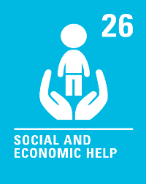 | Democracy - Often, when we stand up or ask for help as a group or community, our collective voices can be more powerful than as an individual.
14th  September | A number of charities, including Streets Kitchen and the Glass Door Homeless Charity, are campaigning for empty commercial buildings to become makeshift shelters this winter. | How can we help those without a home? | 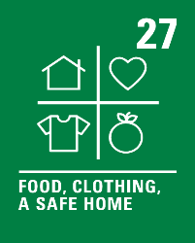 | Mutual Respect - We all have different living arrangements, with some people not having a home at all. There are many reasons for the different circumstances in which people live; it is important to show equal respect to all.
21st  September | A charity is seeking a review of the government guidance on care home visits. John's Campaign says many care homes in England are still refusing regular face-to-face visits, despite changes at the end of July that outlined new guidance for visitors. | Should visits to care homes be allowed? | 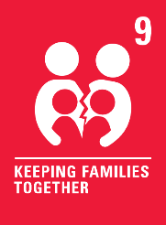 | Rule of Law - Visits to care homes are currently only allowed if certain rules are followed. Rules are often used to help keep us all safe.
28th  September | It has been announced by Prime Minister, Boris Johnson, that Covid marshals will be introduced in towns and city centres in parts of the UK, to help ensure social distancing rules are followed. | Should you always report those who aren’t following rules? |  | Rule of Law - There are many new rules and laws that have been introduced to keep us safe during the Covid-19 pandemic. It’s important to understand why these rules have been made and how they help us.
5th  October | A Spanish triathlete has received praise from all around the world for letting his opponent win third place in the race after he took a wrong turn. | Should you always try to win? | 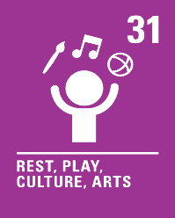 | Individual Liberty - In life there are many different kinds of races. We may win some, we may lose some but all of them take courage and determination to ensure we try our best.
12th October | Sir David Attenborough has celebrated the efforts of young people who have “woken up the world to the threat of climate change.” | Is it the responsibility of young people to protect the planet? | 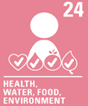 | Mutual Respect - If I try to do what I can to protect our amazing planet, it will create a better world for everyone to live in.
19th October | There are many different ways in which we can fundraise to help others, when doing so, it’s important that we think about the wider impact of our actions. | Is selling red noses a good way to raise money for charity? |  | Democracy - We live in a country where we can express our opinions freely. If there is an issue that is important to us, such as making red noses out of something other than single use plastic, we have a voice to make a change.

