Week | News story | Focus question | UN Article | British value
24th  August | Property information site, Zoopla, have said there was a surge of activity during the first month of lockdown, when virtual reality (VR) viewings of new-build properties tripled. | Where would you like to go using virtual reality? | 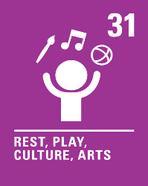 | Individual Liberty - Virtual reality helps us to explore lots of different places without having to go to them. When using virtual reality, we can choose where we go exploring whether it is under the sea, visiting dinosaurs or even venturing into space!
31st  August | A mother, who has recently set up a not-for-profit company to provide toys for children with disabilities, has been told her toys are empowering for children by one of her customers. | What toys do you have at home that are special to you? | 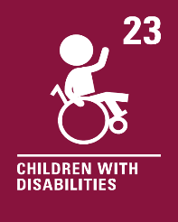 | Mutual Respect - We are all different and should respect and celebrate our own and others’ differences.
7th  September | A tribe in Brazil have chosen to block a highway that cuts through the Amazon as the Brazilian government is not complying with a list of demands that includes aid to help with the impact of COVID-19. | What is it like where you live? | 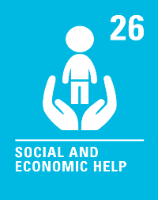 | Democracy - Sometimes people get cross about things that are happening in their country. The Kayapo people are working together to try and get their voices heard.
14th  September | A number of charities, including Streets Kitchen and the Glass Door Homeless Charity, are campaigning for empty commercial buildings to become makeshift shelters this winter. | How could you turn an office into a home? | 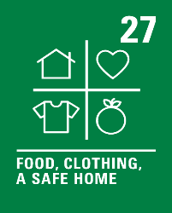 | Mutual Respect - Every family has a different home and some people don’t have a proper home at all. It is important that we show respect to everyone, no matter where they live.
21st  September | A charity is seeking a review of the government guidance on care home visits. John's Campaign says many care homes in England are still refusing regular face-to-face visits, despite changes at the end of July that outlined new guidance for visitors. | Should visits to care homes be allowed? | 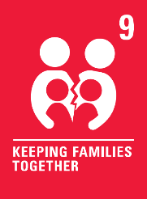 | Rule of Law - Lots of people who live in care homes have not been able to see their families since the coronavirus began. Rules have been put in place to help keep people safe.
28th  September | It has been announced by Prime Minister, Boris Johnson, that Covid marshals will be introduced in towns and city centres in parts of the UK, to help ensure social distancing rules are followed. He believes that the public want to see ‘stronger enforcement’ of the rules. | Why do we have rules at school? | 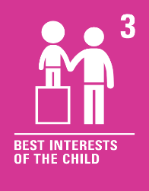 | Rule of Law - There are many rules for us all to follow at home, school and when we are out and about. We must all try our best to stick to the rules. They are there to help us all stay safe.
5th  October | A Spanish triathlete has received praise from all around the world for letting his opponent win third place in the race after he took a wrong turn. Diego Mentriga allowed Britain’s James Teagle to finish ahead of him in the Santander Triathlon, after he made the wrong turn towards spectators less than 100 metres from the finish line. | Should you always try to win? | 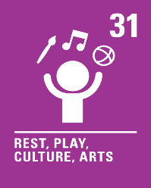 | Individual Liberty - Lots of people enjoy running races. Some people try hard to win and some people just enjoy taking part and having fun.
12th  October | Sir David Attenborough has celebrated the efforts of young people who have “woken up the world to the threat of climate change.” Sir David became the fastest person to have one million followers on Instagram recently after he joined the social media platform to reach out to younger people, many of whom support his message of protecting the natural world. | How can we all help to look after our world? | 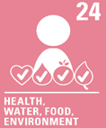 | Mutual Respect - If I try to do what I can to protect our amazing planet, it will create a better world for everyone to live in.
19th  October | There are many different ways in which we can fundraise to help others, when doing so, it’s important that we think about the wider impact of our actions. | What do you think of red noses? | 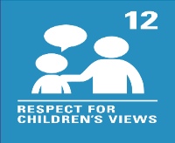 | Democracy - Comic Relief’s red noses will not be made from plastic anymore, thanks to children who said they want to reduce the amount of plastic waste we have. We can all have our say about things that happen in our country, to try and make the world a better place for us all to live in.
Autumn Part 1 2020
COVERAGE

